Header Menu: <https://www.simform.com/>

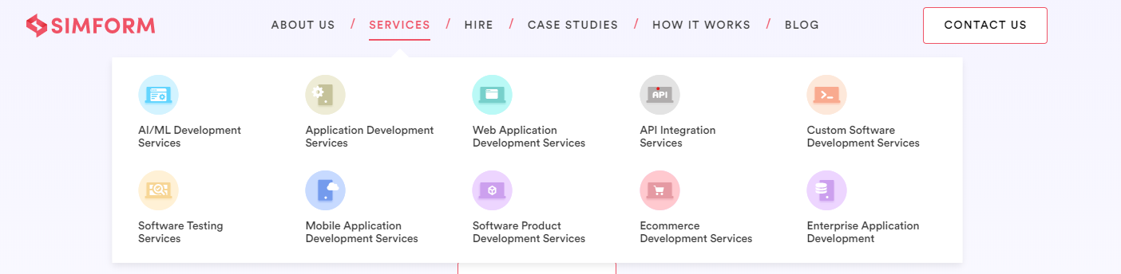

Menu Options:

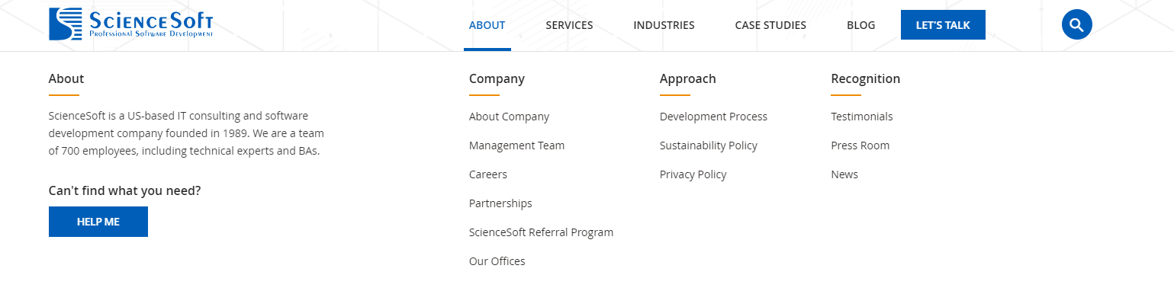About – <https://www.scnsoft.com/>

**Company-** About Wiztecbd , Our Team , Company profile ,Careers , Affiliate Program

**Approach –** Development Process, Sustainability Policy, Privacy Policy [Like : as [scnsoft.com/](https://www.scnsoft.com/)]

**Recognition -**Testimonials, Press Room, News [Like : as [scnsoft.com/](https://www.scnsoft.com/)]

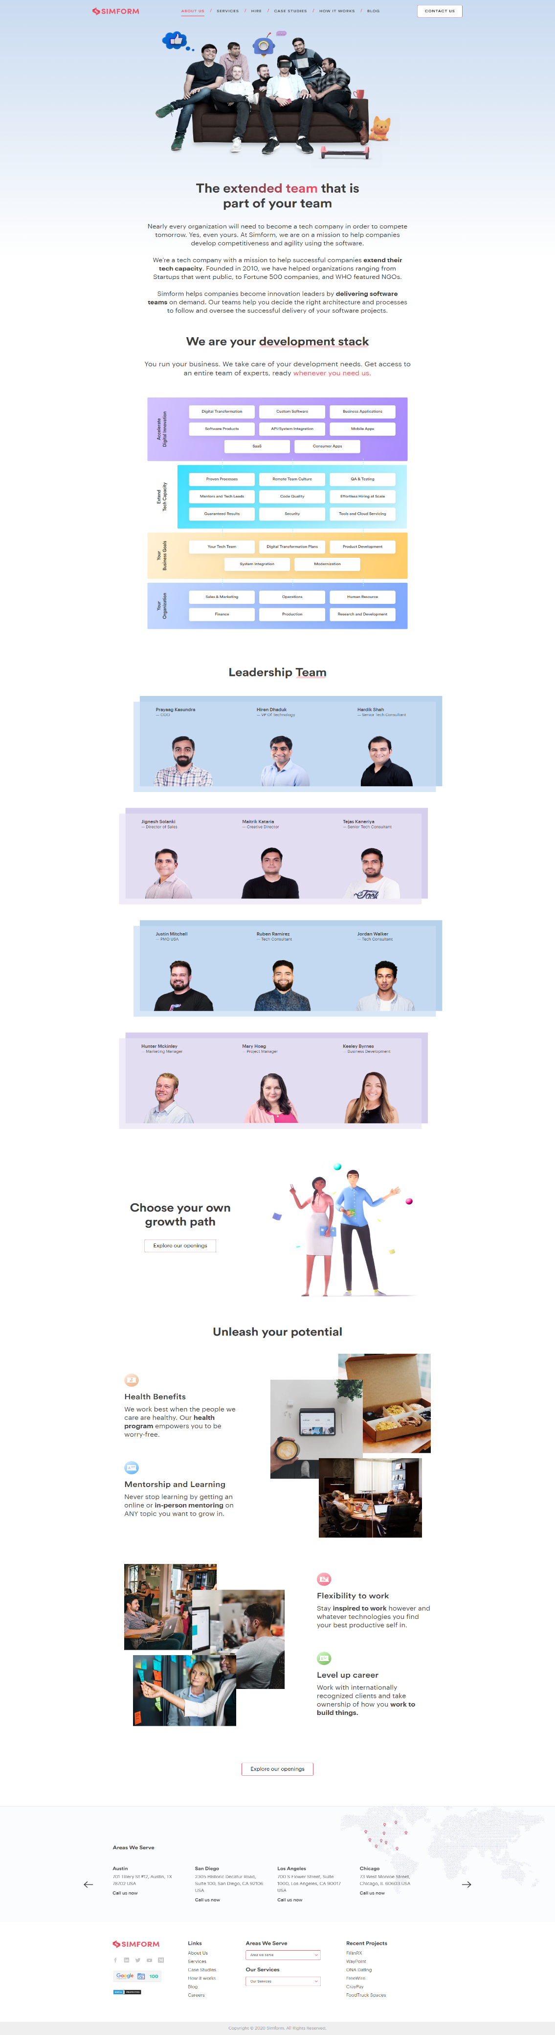**About Wiztecbd :** <https://www.simform.com/about-us/>

<https://www.oxagile.com/company/>

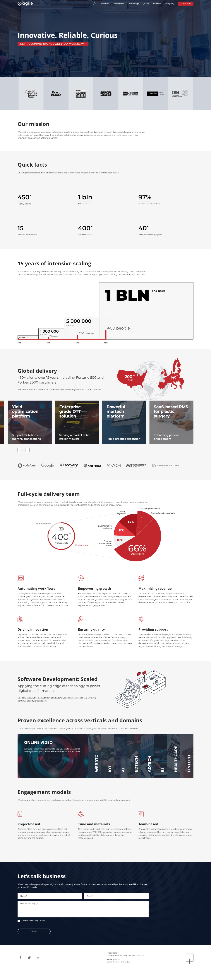

**Our Team :** <https://eleks.com/about-eleks/leadership-team/>

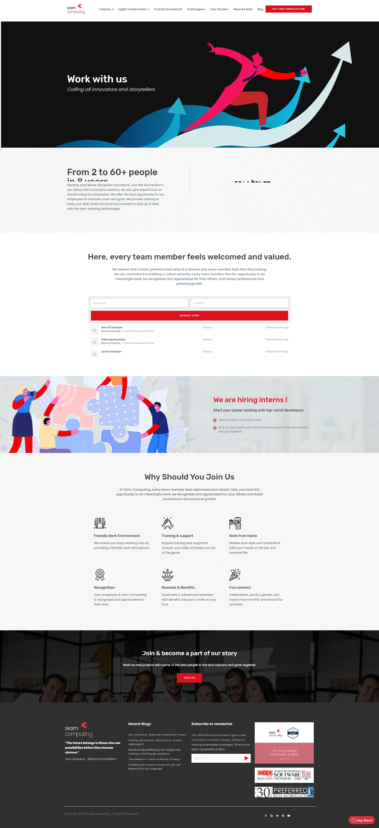**Careers :**

<https://www.simform.com/careers/>

<https://siamcomputing.com/careers/>

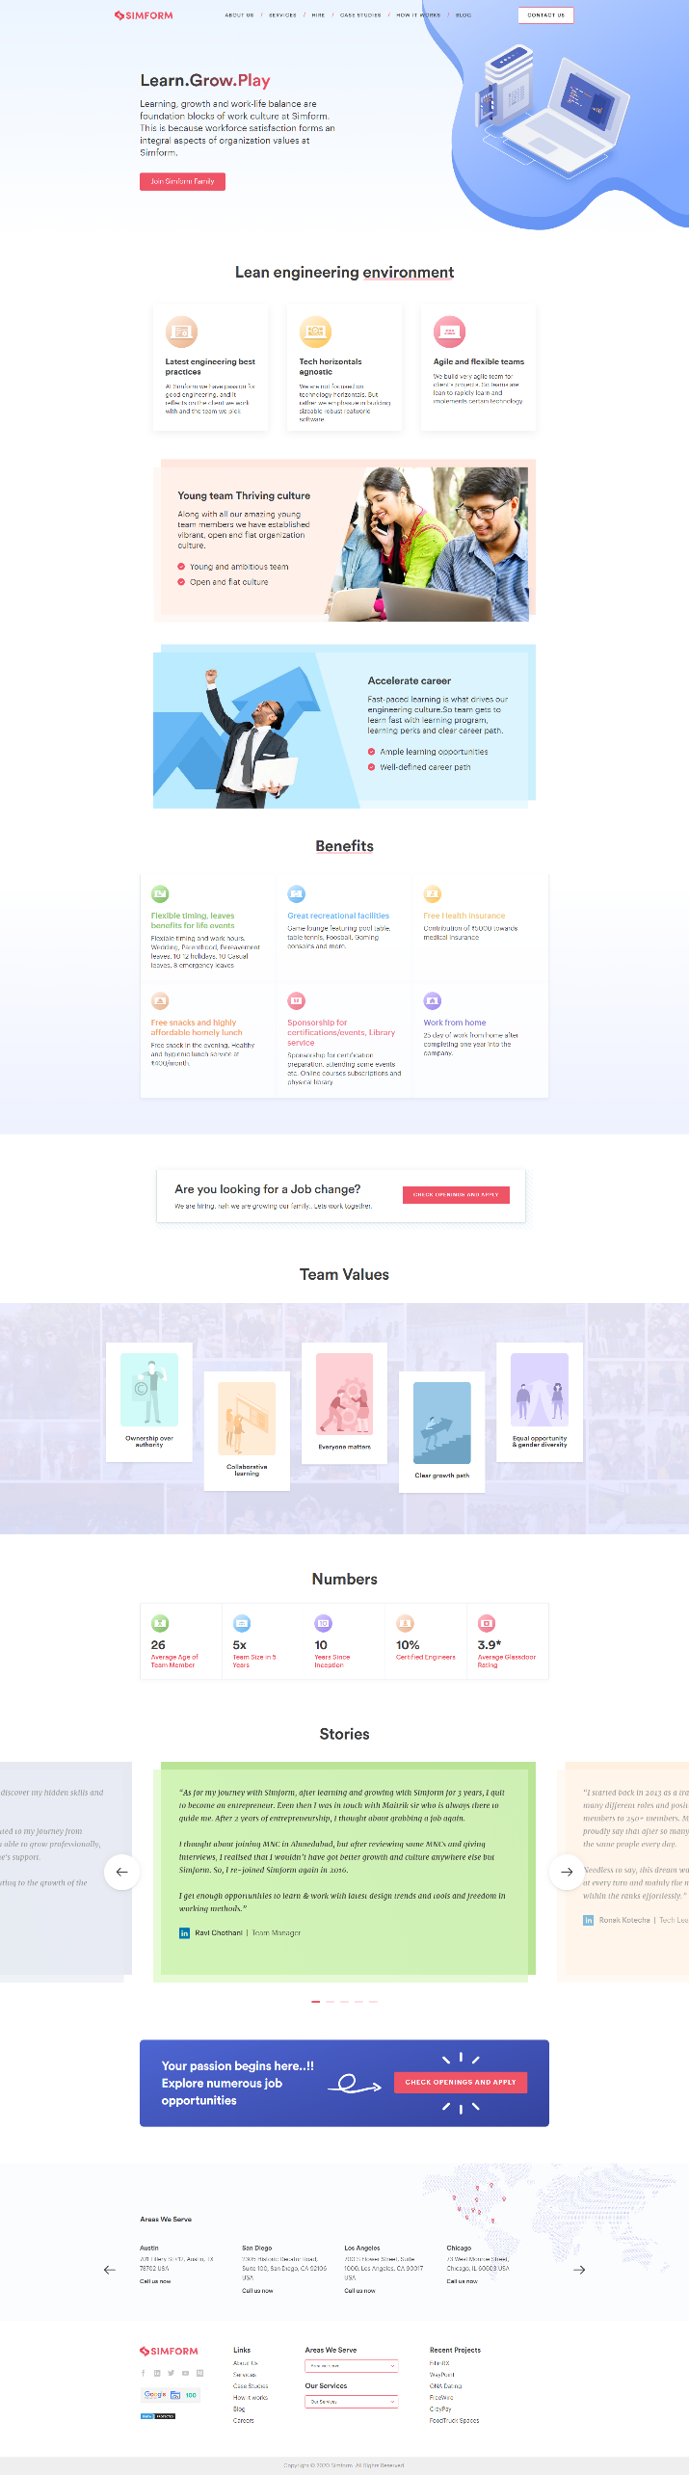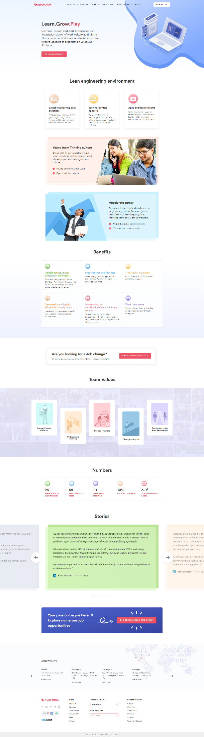

<https://www.simform.com/careers/>

Apply Page : <https://www.simform.com/current-openings/>

**Referral Program (new name Affiliate with us) :** <https://www.scnsoft.com/about/referral-program>

**Note : Need a contact for Referral contact Form

**Menu Option**

**Services :** <https://www.simform.com/>



1.Web Design & Development

2. Mobile Application Development

3. Digital Marketing

4. E-Commerce

5. Custom Software Development

6. UI/UX Design

7. Corporate IT support

8. IT-CONSULTANCY

9. Graphics Design

10. Enterprise application development

**1.Web Design & Development:**

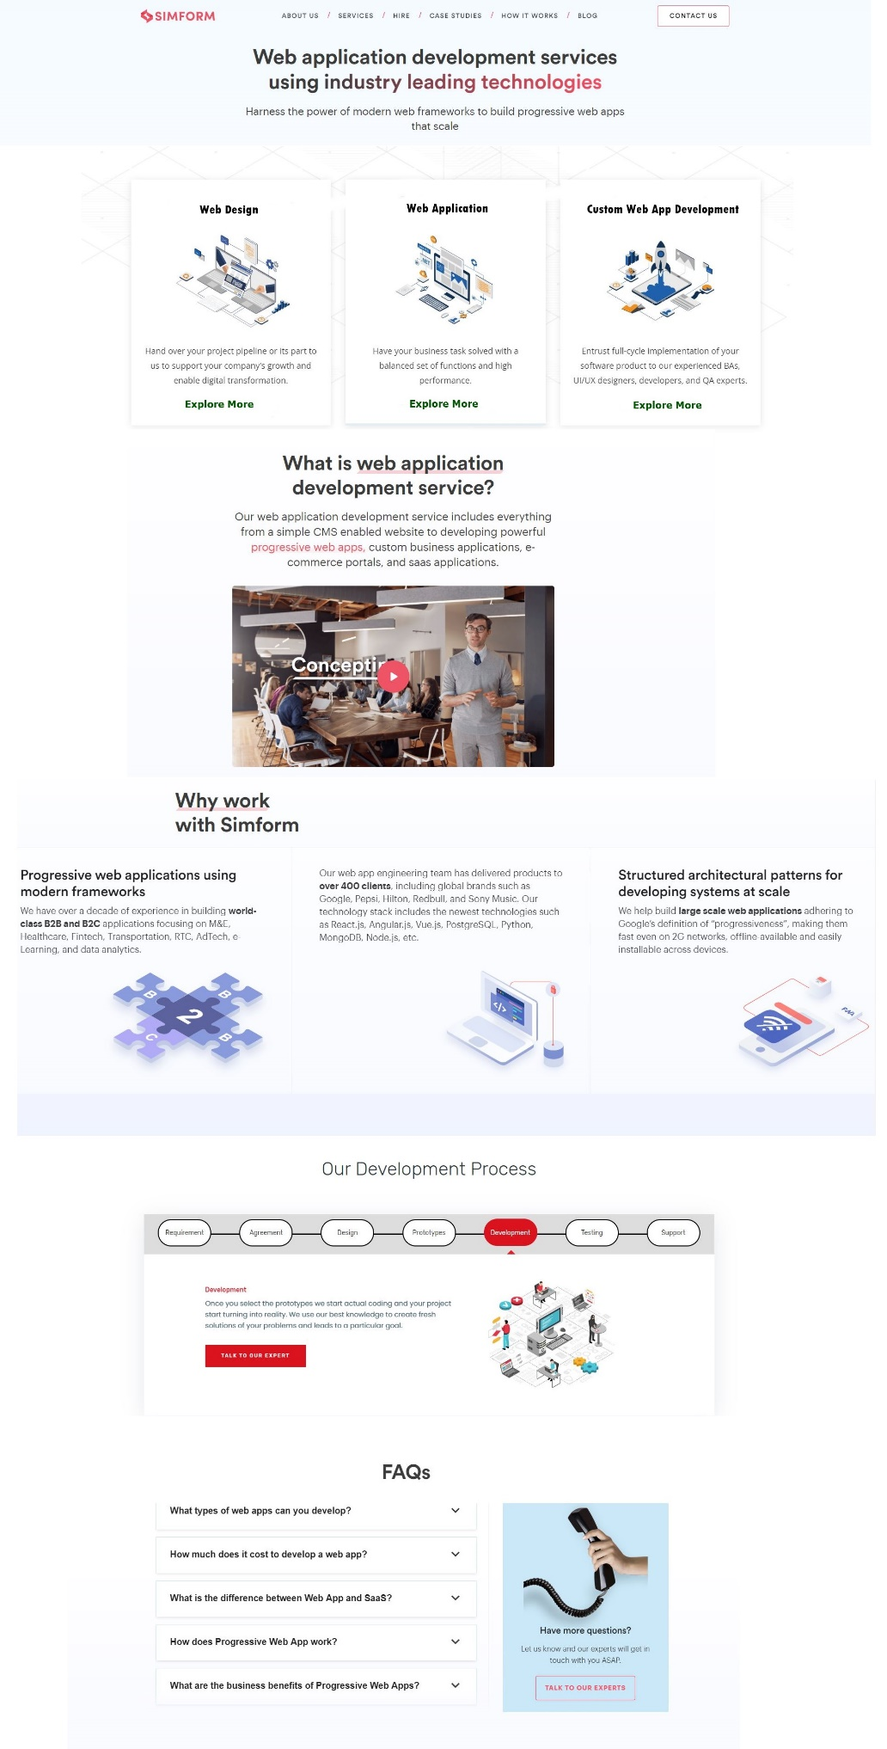

a. Web Application

b. Web Portal Development

c. Custom Web App Development

<https://www.scnsoft.com/>

<https://www.simform.com/services/web-apps-development/>

<https://www.simform.com/services/web-apps-development/>

<https://siamcomputing.com/digital-transformation/web-app-development/>

<https://www.simform.com/services/web-apps-development/>

a. Web Application [<https://siamcomputing.com/digital-transformation/web-app-development/>]

b. Web Portal Development [<https://siamcomputing.com/digital-transformation/web-portal-development/>]

c. Custom Web App Development [<https://siamcomputing.com/digital-transformation/custom-web-app-development/>]

**2. Mobile Application Development :**

a. Android Development

b.iOS App Development

<https://siamcomputing.com/digital-transformation/mobile-app-development/>

c.React Native App Development

d.Progressive Web Application

Like web Design & development page [<https://www.simform.com/services/mobile-app-development/>]

**3. Digital Marketing: like this pattern (**[**https://siamcomputing.com/digital-transformation/web-app-development/**](https://siamcomputing.com/digital-transformation/web-app-development/) **)**

a. Social Media Marketing <https://www.scnsoft.com/services/it-consulting>

b. SEO <https://www.scnsoft.com/services/it-consulting>

C. Content Marketing <https://www.scnsoft.com/services/it-consulting>

d. Email Marketing <https://www.scnsoft.com/services/it-consulting>

like this link pattern

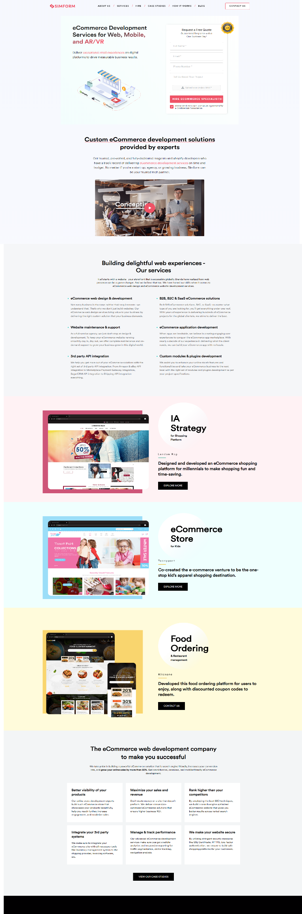**4. E-Commerce:**

<https://www.unifiedinfotech.net/services/ecommerce-website-development/>

<https://www.simform.com/services/ecommerce-development/>

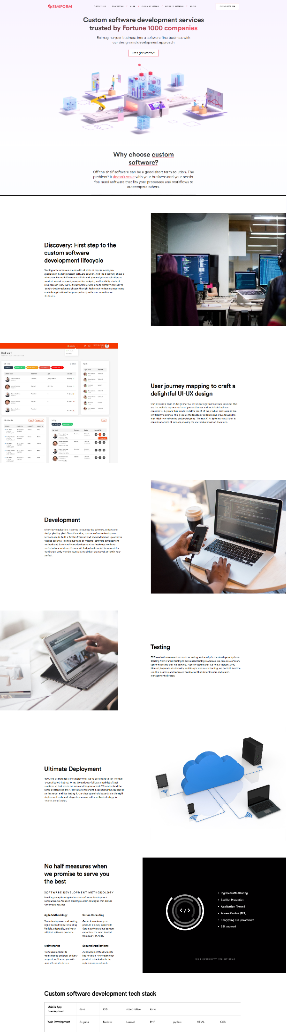**5. Custom Software Development:**

<https://www.simform.com/services/custom-software-development/>

<https://www.unifiedinfotech.net/services/custom-software-development/>

**6. UI/UX Design:**

<https://siamcomputing.com/digital-transformation/ui-and-ux-consulting/>

**10. Enterprise application development**

<https://siamcomputing.com/digital-transformation/enterprise-web-app-development/>

**Main Manu**

**Products :** Same to <https://www.wiztecbd.com>

**Technologies** : <https://siamcomputing.com>

**Hire :** <https://www.simform.com/hire/> [ fully like all Hire options ]

**Industries**

[**https://eleks.com**](https://eleks.com)

[**https://eleks.com/industries/media-entertainment-software-development/**](https://eleks.com/industries/media-entertainment-software-development/)**( every pages look like same pattern )**

**Healthcare**

**Retail & E-commerce**

**Marketing & Advertising**

**Telecommunications**

**Education**

**Transportation and Logistics**

**Agriculture**

**Media & Entertainment**

**Government**

Insights: <https://www.fingent.com>

1. Blog <https://intersog.com/blog/>

2. Case studies <https://www.fingent.com/case-studies/>

3. Infographics <https://www.fingent.com/infographics/>

4. Video (youtube link)

Footer have some menu :

1. How it Works <https://siamcomputing.com>
2. How we work - <https://eleks.com/about-eleks/how-we-work/>